Konrad Lisowski 213763962

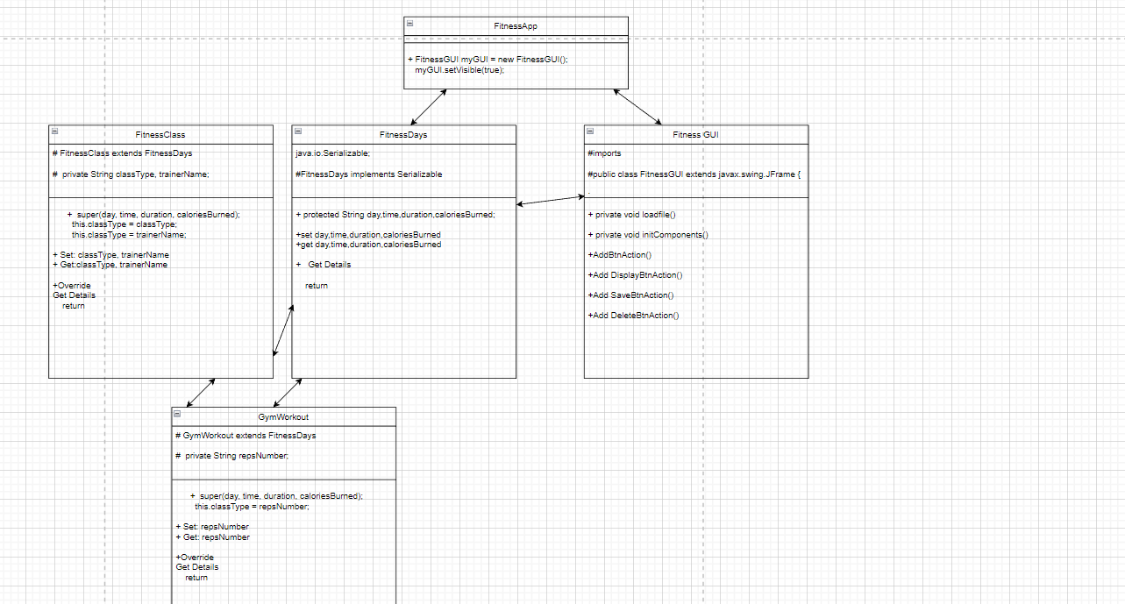

|  |  |  |  |  |  |  |
| --- | --- | --- | --- | --- | --- | --- |
| **Test #** | **Description** | **Test Data** | **Expected Result** | **Actual Result** | **Pass/Fail** | **Comments** |
| 1 | Check if Add and Display buttons works | Day = Today, Time = 1pm, Duration = 20 Seconds, Calories burned = 10, Gym workout, Number of rep’s = 2 | The data entered is displayed after pressing add and display | The data entered is displayed after pressing add and display | Pass | It works as it should |
| 2 | Check if Save and load buttons work | After the previous test I press save then reopen the file and press display | The data was saved and is being displayed again | The data was saved and is being displayed again | pass | It works as it should |
| 3 | Check if the delete First entry works on the list | I click delete first entry and click display | Nothing should appear | Nothing appears | pass | It works as it should |
| 4 | Check if the delete first entry works for the file array too | I close and reopen the file and click display | Nothing should appear | Nothing appears | pass | It works as it should |
| 5 | Check if both options work by selecting fitness class this time | Day = Today, Time = 1pm, Duration = 20 Seconds, Calories burned = 10, Fitness class, Class type = work, Trainer Name = Bob | The data entered is displayed after pressing add and display | The data entered is displayed after pressing add and display | pass | It works as it should |

